CS532 Software Engineering Project Notebook

ICE TRACK System

Professor Leonard

March 10, 2016

Team ICE TRACK

Dustin Bonilla

Eric Ly

Ali Saadati

Mohammed Alshahrani

Anass Benothmane

Colan Kirk

1. Test Results Report
   * 1. List of tests executed and results …

***\*See Requirements Matrix Columns P, Q, and R***

* + 1. Defect discovery profile ...
* Track the item's quantity.
* Manage shipped orders.
* Track pending orders.
  + 1. Defect closure profile …
* Item’s quantity are now tracked and updated in the database every time an order item is performed.
* orders tagged as shipped are now stored and retrievable from database.
* Defect is currently being debugged.

1. Code review/inspection notes (optional\*)
2. Unit test plan

***\*See Requirements Matrix Columns L - O***

1. Unit test review/inspection notes (optional\*)

1. Unit test/retest results

* 1. 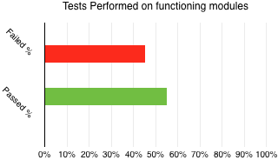   
     The time we had allowed us to perform a first round of unit/ database tests. The results were 9 out of 20 tests failing a majority of the criteria while 11 out of 20 tests passed a majority of the criteria for the tests.
  2. DDR During the implementation phase : 15/3 \* 100 = 500

1. Integration test plan
2. Integration test review/inspection notes (optional\*)
3. Integration test/retest results